Atmospheric CO₂ and ocean acidity

What prior knowledge do you already have about the levels of carbon dioxide in the atmosphere?

CO2 is essential to life on Earth. Although CO2 occupies only about 0.04% of the total mass of the atmosphere, this concentration is sufficient to sustain life.

Study the following three equations below which have been proposed to occur in the environment:

Equation 1: CO₂(g) ⇌ CO₂(aq)
Equation 2: CO₂(aq) + H₂O(ℓ) ⇌ H₂CO₃(aq)
Equation 3: H₂CO₃(aq) ⇌ HCO₃⁻(aq) + H⁺(aq)
(Recall that H₂CO₃ is carbonic acid, a weak acid that partially ionises in solution to form H⁺)

Using your knowledge of chemical equilibrium, predict how increasing levels of atmospheric CO₂ will affect the three equilibrium reactions.

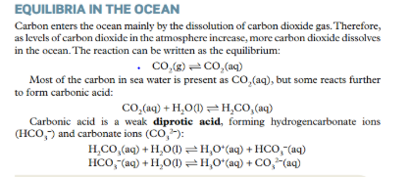

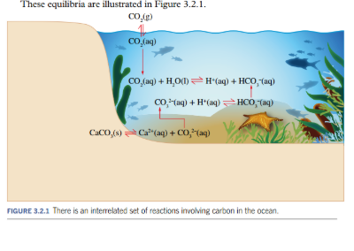

Write a hypothesis relating atmospheric CO₂ levels and pH of surrounding water in contact with the CO₂.

____________________________________________________________________________________________________________________________________________________________________

Ocean acidification is the decrease in pH that is occurring due to the absorption of CO2 from the atmosphere.

CO2 gas , as with other gases, is more soluble in cold water. As a result, ocean acidification is greater in the polar regions.

Carbonate equilibria
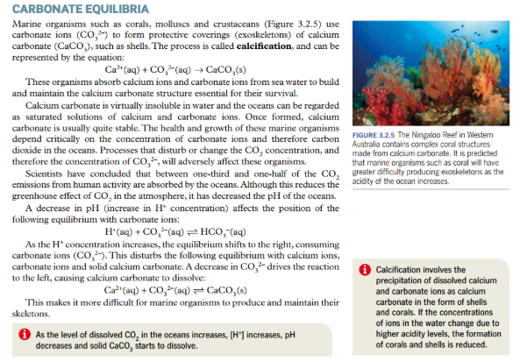

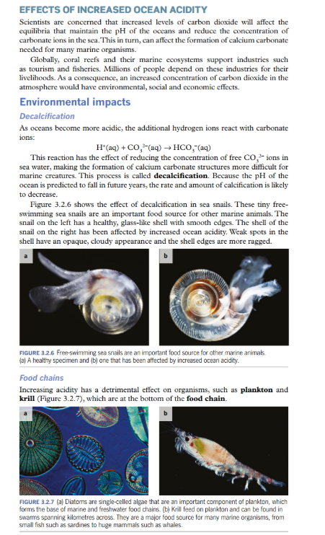

Krill eggs will not hatch successfully at a lower pH. Increased ocean acidity have a harmful effect on the species of plankton and krill as other species depend for their survival. A collapse of krill population along with ocean warming would have a disastrous effect on the ecosystem of the ocean.

Social and economic impacts
Increased ocean acidity will have social and economic impacts, particularly people in coastal communities. Increased ocean acidity will potentially affectfood supplies, coastal protection and tourism.

